# Lab 0. Setting up the experimental designer & activate your community license

## Task: Select the new Power Automate Designer :

At the time of writing the new Flow designer is still in experimental stage. To select the new designer,

1. Go to : <https://flow.microsoft.com>
2. 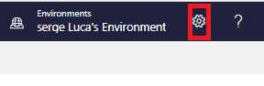Click on the “**Setting**s” button Or “**Gear**” icon as shown below :
3. Click on the “**View all Power Automate settings”** :

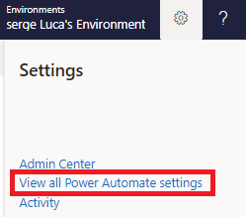

1. Select the option “**Experimental Features”** if it is not already selected and hit the “**Save**” button:

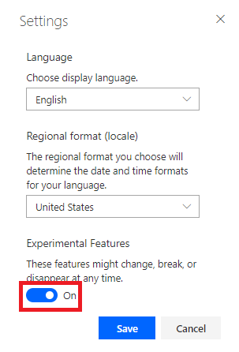

## Task: Activate your Community license

The Office 365 license provides you with a Standard Power Apps and Power Automate license which is good enough for the most labs. However, some labs require a Premium connector; the Community license give you access to **Premium features** of the product for free. The main restriction with the Community license is that flows, and applications created with the Community license cannot be shared with other users.

To Activate community license, follow the steps as listed

1. Go to <https://powerapps.microsoft.com/en-us/communityplan/> and click on “Get started for free”

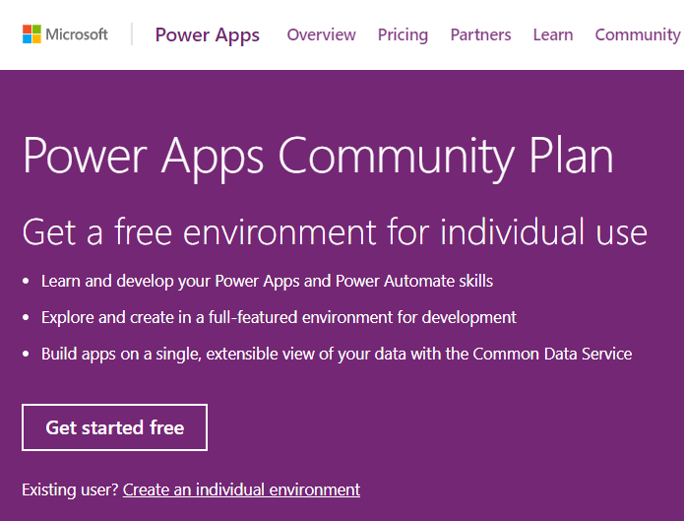

1. Enter your e-mail address and click on “Sign up”:

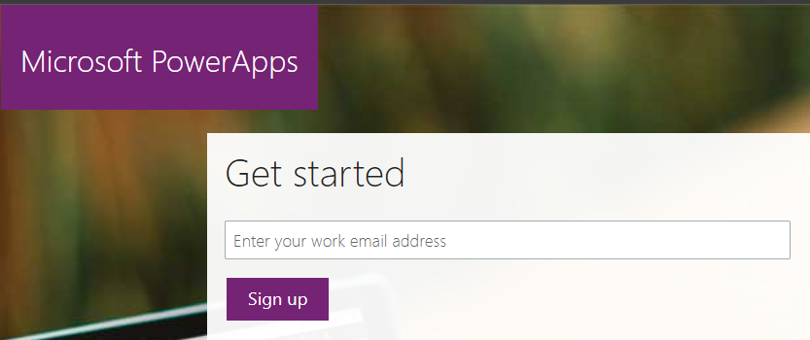

1. And Click on the “Sign-in” :

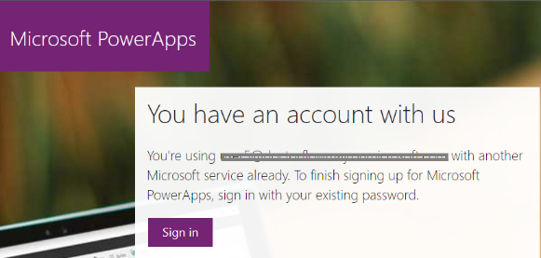

1. Finally click on the “Start” to complete the activation:

